Designer Purse Bingo  Here’s How it works . . .  - All Bingos will have one winner per game.  - Cash Winners – Tiebreaker winnings will be divided amongst verified winners.  - Purse Winners – Tiebreaker will be determined by drawing the higher card.  - Runners-up will receive $20.00  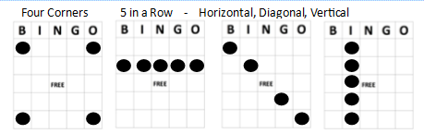  More ways to win…  - Silent Auction  - Tickets 25/$20.00  - Mystery Purse  - Tickets $25  - 50/50 Raffle  - Tickets 10/$10.00 – 25/$20.00  - Game(s) of Chance  - 1 Pull ticket for $1.00  - Winner receives - * Varies by game  - Additional Bingo Cards  - Games 1-15 purchase additional Bingo Cards for 3/$5.00 and 6/$10.00  - Game 15 (Sold Separately)  - Bingo Cards 3/$3.00 or 6/$5.00  Coverall Bingo  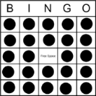  Credit Cards Accepted: | Designer Purse Bingo  - Game 1 – (add border color)  Regular Bingo  - Game 2 – (add border color)  Regular Bingo  - Game 3 – (add border color)  Regular Bingo  - Game 4 – (add border color)  Postage Stamp  Prize - $50.00  - Game 5 – (add border color)  Regular Bingo  - Game 6 – (add border color)  Regular Bingo  - Game 7 – (add border color)  Regular Bingo  - Game 8 – (add border color)  LETTER “X”  Prize - $100.00  - Game 9 – (add border color)  Regular Bingo  - Game 10 – (add border color)  Regular Bingo  - Game 11 – (add border color)  Regular Bingo  - Game 12 – (add border color)  LETTER “T” for Thank You for your Support!  Prize - $150.00  - Game 13 – (add border color)  Regular Bingo  - Game 14 – (add border color)  Regular Bingo  - Game 15 – (add border color)  Cover All  Designer Tote

